

Welcome back to term 2, for what is sure to be a fun filled term with shenanigans aplenty, and to start it off we’ve got a jam-packed week ahead. With Big Night’s, stranger danger, and luscious locks aplenty, as well as the obligatory sports games, this is a week which will leave you begging for more holidays so that you can rest your weary body. And Canberra will oblige, with the Anzac day long weekend. So get pumped, get excited, for term 2!

*Doing it for Bill since 2014*

THE BRUCE BILLITIN

**ISSUE 09: Monday 18th April- Monday 25th April**

*Doing it for Bill since 2014*

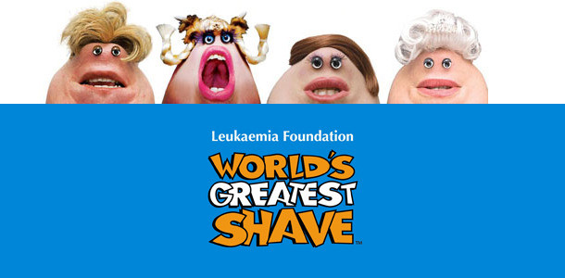

ANZAC DAY CEREMONIES  
**25TH April, Australian War memorial**

Anzac day is an important day in Australia’s history, and there is no better place to commemorate it than our nation’s capital. The Billitin recommends heading to the dawn service at **5:30am**, however there is another service at **10:30am.**

GROOVIN THE MOO 2016  
**24th April, University of Canberra 10:30am**

Groovin the Moo is back with a massive lineup including Boy and Bear, Alison Wonderland, British India, MS MR and more. Tickets are still available from the GTM website, so if you need something to do this Sunday, then this seems like a great option!

CELESTIAL EMPIRE EXHIBITION  
**Open Daily from 10am at the National Library**

See the exquisite selection of precious objects from the national library of China, now available in Australia, to gain an insight into Chinese culture and tradition. This is a landmark exhibition, and one which allows the visitor to glimpse the world of China’s last imperial dynasty, both from an Eastern and Western perspective.

CANBERRA TOY AND HOBBY FAIR  
**9-3pm 23rd April University of Canberra High School**

Got a passion for model cars? Love that lego? Can’t get enough trademark sports cards? Then this is the fair for you! Head down for a day which celebrates all hobbies, and gives you the option to get some amazing deals on toys. Come on, lets all go back to our childhood!

Harvey has confirmed that these are actual portraits of the people doing World's greatest shave this year

PLEDGE WEEK  
**All week, multiple events**

This week marks the start of the Pledge campaign for 2016, a campaign to address interpersonal violence, condemn victim blaming and promote ethical bystander behaviour. Keep an eye peeled on both the Pledge Launch Week facebook page, and banter, as the GSA advocates will be leading walking groups to events and to go and sign the pledge.

IMPLICATIONS OF THE US PRESIDENTIAL ELECTION FOR THE AUSTRALIA-US RELATIONSHIP

**6-7.15pm Llewellyn Hall**

Join recently returned Australian Ambassador Kim Beazley as he reflects on his time as ambassador and provides an Australian perspective on the current primaries. This lecture will be followed by a discussion between Mr Beazley and the US ambassador to Australia John Berry.



*Where is the love? -* Bill.I.am



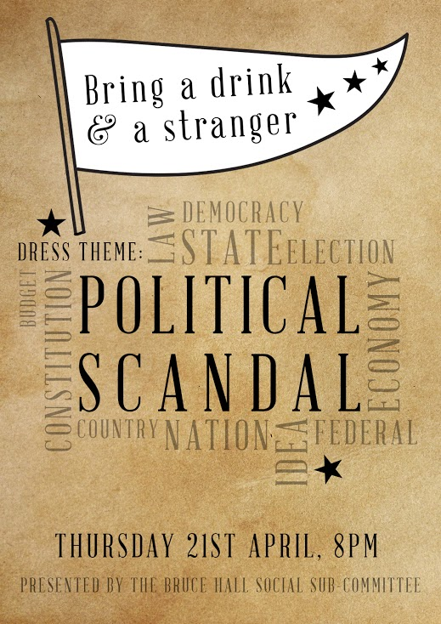

BIG NIGHT IN

**Sunday Night in South Quad**

Come on up and see our very own Bruce band perform the songs that they have been practising so hard for the past couple of weeks. They’ve put a lot of effort into this and would love your support, and hey, if you haven’t got tickets for Groovin the Moo, then this will more than make up for it. There will also be open mic performances aplenty, and if you are still keen to do a performance then don’t hesitate to send our awesome arts reps a message.

BRUCE’S GREATEST SHAVE

**Saturday 3:30pm in South Quad**

One of Bruce’s biggest fundraising events, and an entertaining one for everyone (who doesn’t like seeing their friends suffer under the razor?). This event will be run in an auction style, with everyone getting the opportunity to bid for the privilege of shaving their friends, or waxing those brave (read: stupid) few who have volunteered. There are several hair-related options over the course of the event which are as follows:

* THE SHAVE: The big event, with a couple of brave souls from Bruce putting their name forward to be at the mercy of the audience. Keep an eye on Banter for shaver bios and info as to how you can donate.
* WAXING : Nominate yourself for this trial by pain, and announce which body part you’re willing to shave. Wax strips may be bought by those who wish to help their friends achieve that silky smooth feel that Chris says is ‘unbeatable’.
* COLOURING HAIR: You don’t have to shave to be brave, you can also dye your hair an unusual colour of your choosing

It is not too late to sign up for any of these options, so if you are keen chuck a message to Harvey and get involved!



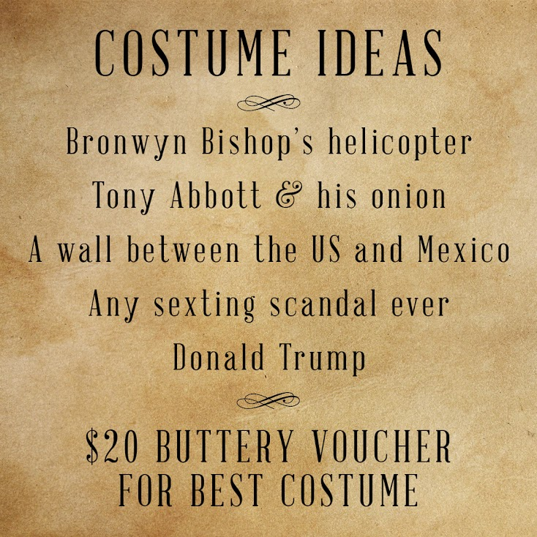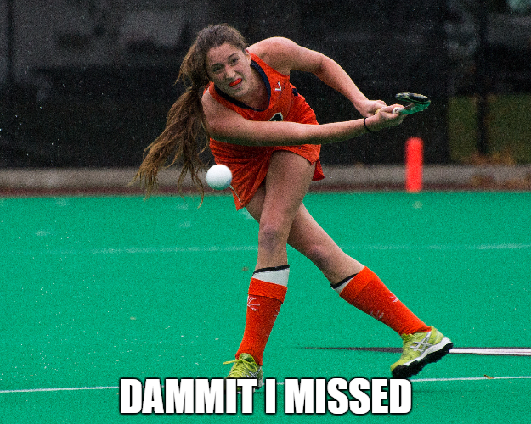

TRIVIA

1. Which pub in Canberra is named after a famous prohibitionist? 7. Which actor played the man character in the film Gladiator?

2. To the nearest 10 000, what is the population of Liechtenstein? 8. What is the chemical formula of glucose?

3. What was the first country invaded in World War 1? 9. Who wrote the literary classic Frankenstein?

4. What is the second largest country by land mass? 10. What is the longest bone in the human body?

5. What year was the first super bowl played?

6. The phrase ‘let them eat cake’ is commonly attributed to who?

1. King O’Malleys, 2. 40 000, 3. Serbia, 4. Canada, 5. 1967, 6. Marie Antoinette, 7. Russel Crowe, 8. C6H12O6, 9. Mary Shelley, 10. The Femur.

Sports Training Times

**Ultimate Frisbee Mens Hockey Womens Hockey**4pm Wednesday, 8am Monday 8am Monday  
10:30 Sunday, 4pm Thursday 4pm Thursday

**Games:**

Mens Hockey 10:30am on Friday

Womens Hockey at 1:30pm Friday

Frisbee 2pm Saturday